INDEX
Sr. No. | Date | Title | Pg. No. | Sign
A |  | Data Cleaning and Pre-processing
1 |  | Read a CSV file and display the first 5 rows
2 |  | Identify missing values in each column
3 |  | Fill missing numeric values with column mean
4 |  | Fill missing categorical values with mode
5 |  | Remove duplicate records from the dataset
6 |  | Convert a column datatype (Age to int)
7 |  | Replace negative salary values with median salary
8 |  | Rename columns for better readability
9 |  | Reorder columns in a desired sequence
10 |  | Use NumPy to replace all NaN values in a 2D array with zero
B |  | Data Transformation and Normalization
1 |  | Standard Scaling using NumPy
2 |  | Min-Max Normalization
3 |  | Log Transformation
4 |  | DataFrame Transformation using Pandas
5 |  | Handling Missing Data
6 |  | Detecting Missing Values
7 |  | Label Encoding a Categorical Column
8 |  | One-Hot Encoding
9 |  | Descriptive Statistics
10 |  | Correlation Matrix
C |  | Data Visualization using Matplotlib and Seaborn
1 |  | Line Plot using Matplotlib
2 |  | Bar Chart using Matplotlib
3 |  | Histogram using Matplotlib
4 |  | Pie Chart using Matplotlib
5 |  | Scatter Plot using Matplotlib
6 |  | Box Plot using Seaborn
7 |  | Violin Plot using Seaborn
8 |  | Heatmap using Seaborn
9 |  | Pairplot using Seaborn
10 |  | Count Plot using Seaborn
D |  | Statistical Analysis and Outlier Detection
1 |  | Basic Summary Statistics
2 |  | Categorical Summary Statistics
3 |  | Salary Quantiles Calculation
4 |  | Outlier Detection using Interquartile Range (IQR) Method
5 |  | Visualizing Outliers using Boxplot
6 |  | Outlier Detection using Z-Score Method
7 |  | Handling Outliers using Capping Technique
8 |  | Group-wise Mean and Standard Deviation Calculation
9 |  | Missing Value Detection
10 |  | Replacing Outliers with Median Value
E |  | Regression Analysis and Classification
1 |  | Simple Linear Regression – Experience vs Salary
2 |  | Salary Prediction using Linear Regression
3 |  | Regression Line Visualization
4 |  | Multiple Linear Regression
5 |  | Logistic Regression Model
6 |  | Purchase Prediction using Logistic Regression
7 |  | Classification Report Generation
8 |  | Confusion Matrix Visualization
9 |  | Logistic Regression Accuracy Calculation
10 |  | Logistic Regression Probability Distribution
F |  | Time Series Analysis and Forecasting
1 |  | Reading and Parsing Time Series Data
2 |  | Line Plot of Sales Over Time
3 |  | Monthly Sales Resampling and Aggregation
4 |  | Moving Average Calculation using Rolling Mean
5 |  | Seasonal Decomposition of Sales Data
6 |  | ADF Test for Stationarity Check
7 |  | Differencing to Remove Trend
8 |  | Autocorrelation and Partial Autocorrelation Analysis
9 |  | ARIMA Model Forecasting
10 |  | Forecast vs Actual Sales Visualization
G |  | Practical Data Cleaning and Exploratory Data Analysis
1 |  | Data Cleaning and Pre-processing using Pandas and NumPy (Employee Data)
2 |  | Data Cleaning and Pre-processing of Customer Sales Data
3 |  | Data Cleaning, Transformation and EDA using Retail Sales Data
4 |  | Data Cleaning, Pre-processing and Basic Analysis of Sales Data
H |  | Advanced Visualization using Seaborn and Matplotlib
1 |  | Applying Seaborn Style to Matplotlib Plots
2 |  | Customizing Seaborn Line Plot using Matplotlib
3 |  | Overlaying Seaborn and Matplotlib Plots
4 |  | Enhancing Seaborn Histogram with Matplotlib Annotations
I |  | Interactive Visualization using Bokeh
1 |  | Hiding the Legend in Bokeh Plot
2 |  | Muting the Legend in Bokeh Plot
3 |  | Adding Widgets to the Bokeh Plot
4 |  | Creating Tab Widget in Bokeh
J
K
L

ASSIGNMENT 1 – DATA CLEANING & PRE-PROCESSING
1. Read a CSV file and display the first 5 rows
import pandas as pd
df = pd.read_csv("./data/data1.csv")
print(df.head())
2. Identify missing values in each column
import pandas as pd
df = pd.read_csv("./data/data1.csv")
missing = df.isnull().sum()
print("Missing values in each column:")
print(missing)
3. Fill missing numeric values with column mean
import pandas as pd
df = pd.read_csv("./data/data1.csv")
df["Age"] = df["Age"].fillna(df["Age"].mean())
print(df)
4. Fill missing categorical values with mode
import pandas as pd
df = pd.read_csv("./data/data1.csv")
df["Gender"] = df["Gender"].fillna(df["Gender"].mode()[0])
print(df)
5. Remove duplicate records from the dataset
import pandas as pd
df = pd.read_csv("./data/data1.csv")
df = df.drop_duplicates()
print(df)
6. Convert a column datatype (Age to int)
import pandas as pd
df = pd.read_csv("./data/data1.csv")
df["Age"] = df["Age"].fillna(df["Age"].mean()).astype(int)
print(df.dtypes)
print(df)
7. Replace all negative salary values with median salary
import pandas as pd
df = pd.read_csv("./data/data1.csv")
median_salary = df["Salary"][df["Salary"] > 0].median()
df["Salary"] = df["Salary"].apply(
lambda x: median_salary if x < 0 else x
)
print(df)
8. Rename columns for better readability
import pandas as pd
df = pd.read_csv("./data/data1.csv")
df.rename(
columns={
"EmpName": "Employee_Name",
"Dept": "Department"
},
inplace=True
)
print(df.columns)
print(df.head())
9. Reorder columns in a desired sequence
import pandas as pd
df = pd.read_csv("./data/data1.csv")
df.rename(
columns={
"EmpName": "Employee_Name",
"Dept": "Department"
},
inplace=True
)
df = df[
[
"Employee_ID",
"Employee_Name",
"Age",
"Gender",
"Salary",
"Department"
]
]
print(df.head())
10. Use NumPy to replace all NaN values in a 2D array with zero
import numpy as np
arr = np.array([
[1, np.nan, 3],
[4, 5, np.nan]
])
arr = np.nan_to_num(arr)
print(arr)
OUTPUT:
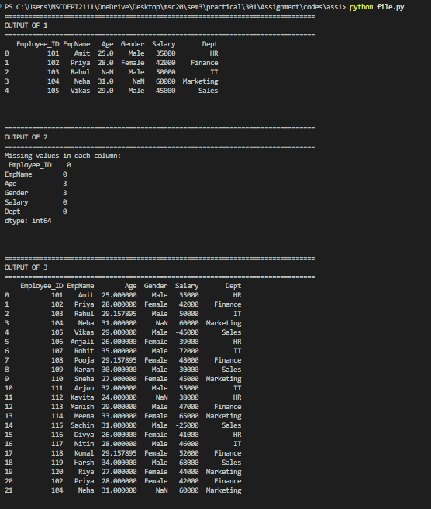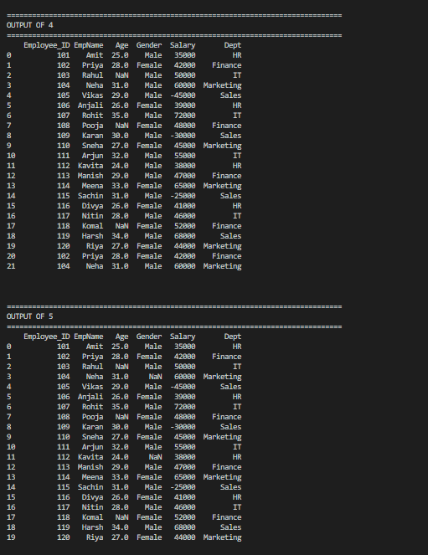
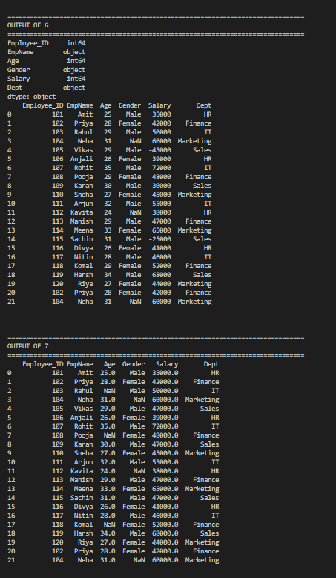
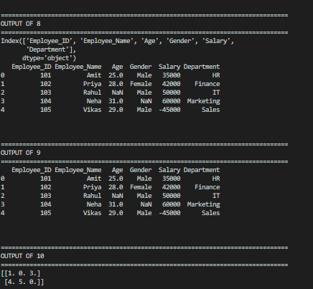

ASSIGNMENT 2 – DATA TRANSFORMATION AND NORMALIZATION
1. Write a Python program to standardize a given dataset using Standard Scaling technique by subtracting the mean and dividing by the standard deviation.
import numpy as np
data = np.array([10, 20, 30, 40, 50])
scaled = (data - data.mean()) / data.std()
print("Scaled Data:", scaled)
2. Write a Python program to normalize a dataset using Min-Max normalization technique and scale the values between 0 and 1.
import numpy as np
data = np.array([15, 25, 35, 45, 55])
normalized = (data - data.min()) / (data.max() - data.min())
print("Normalized Data:", normalized)
3. Write a Python program to perform logarithmic transformation on a dataset using NumPy.
import numpy as np
data = np.array([1, 10, 100, 1000])
log_data = np.log10(data)
print("Log-transformed Data:", log_data)
4. Write a Python program to create a Pandas DataFrame and add a new column by applying a mathematical transformation on an existing column.
import pandas as pd
df = pd.DataFrame({"Value": [1, 2, 3, 4, 5]})
df["Squared"] = df["Value"] ** 2
print(df)
5. Write a Python program to handle missing values in a dataset by replacing them with the mean value of the column.
import pandas as pd
df = pd.DataFrame({"Age": [20, 25, None, 30]})
df["Age"] = df["Age"].fillna(df["Age"].mean())
print(df)
6. Write a Python program to detect and display the number of missing values present in each column of a dataset.
import pandas as pd
df = pd.DataFrame({"Age": [20, 25, None, 30]})
missing = df.isnull().sum()
print("Missing values per column:", missing)
7. Write a Python program to convert categorical data into numerical values using label encoding.
import pandas as pd

df = pd.DataFrame({
"Gender": ["Male", "Female", "Female", "Male"]
})
df["GenderEncoded"] = df["Gender"].astype("category").cat.codes
print(df)
8. Write a Python program to convert categorical variables into binary columns using one-hot encoding.
import pandas as pd
df = pd.DataFrame({ "Gender": ["Male", "Female", "Female", "Male"]})
df = pd.get_dummies(df, columns=["Gender"])
print(df)
9. Write a Python program to generate descriptive statistical information of a dataset.
import pandas as pd
df = pd.DataFrame({"Score": [50, 60, 70, 80, 90]})
print(df.describe())
10. Write a Python program to calculate the correlation matrix between multiple numerical variables.
import pandas as pd
df = pd.DataFrame({
"Math": [85, 90, 78, 92],
"Science": [88, 85, 82, 95],
"English": [80, 78, 85, 88]
})
print(df.corr())

OUTPUT:

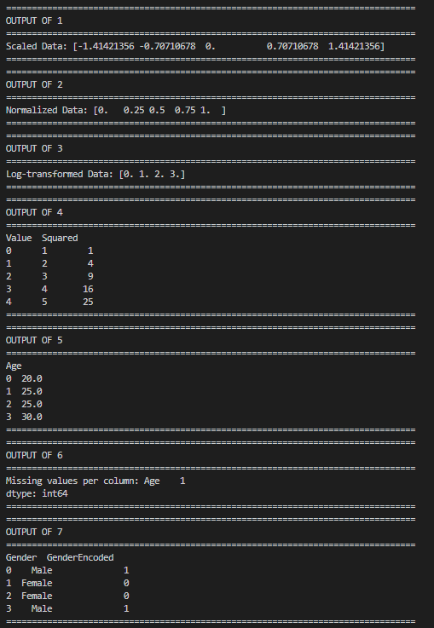
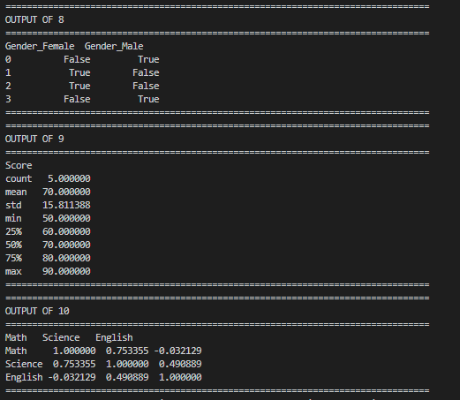

ASSIGNMENT 3 – DATA VISAULIZATION USING MATPLOTLIB & SEABORN
1. Write a Python program to create a line plot using Matplotlib and display the relationship between two variables with proper labels and grid.
import matplotlib.pyplot as plt
x = [1, 2, 3, 4, 5]
y = [10, 20, 25, 30, 35]
plt.plot(x, y)
plt.title("Line Plot")
plt.xlabel("X Axis")
plt.ylabel("Y Axis")
plt.grid(True)
plt.show()

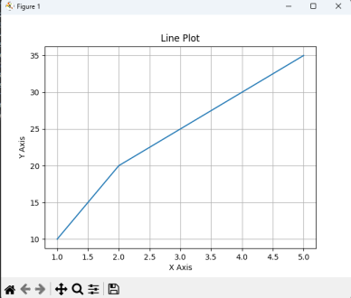
2. Write a Python program to create a bar chart using Matplotlib for representing categorical data.
import matplotlib.pyplot as plt
categories = ['A', 'B', 'C', 'D']
values = [23, 45, 56, 78]
plt.bar(categories, values, color='skyblue')
plt.title("Bar Chart")
plt.show()

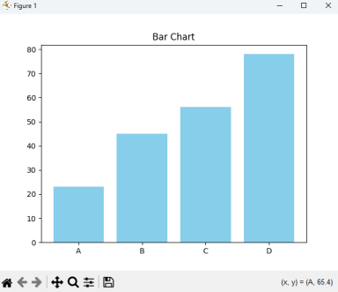
3. Write a Python program to create a histogram using Matplotlib to display the frequency distribution of data values.
import matplotlib.pyplot as plt
data = [12, 15, 22, 23, 23, 24, 25, 26, 28, 30, 35, 40]
plt.hist(data, bins=5, color='orange', edgecolor='black')
plt.title("Histogram")
plt.xlabel("Value")
plt.ylabel("Frequency")
plt.show()

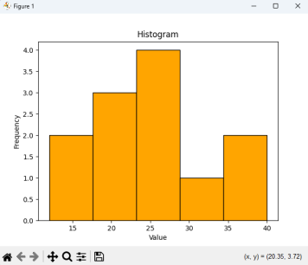
4. Write a Python program to create a pie chart using Matplotlib to represent percentage distribution among different categories.
import matplotlib.pyplot as plt
sizes = [30, 20, 25, 25]
labels = ['Python', 'Java', 'C++', 'JavaScript']
plt.pie(sizes, labels=labels, autopct='%1.1f%%')
plt.title("Pie Chart of Languages")
plt.show()

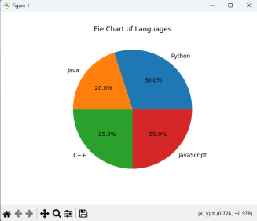
5. Write a Python program to create a scatter plot using Matplotlib to visualize the relationship between two numerical variables.
import matplotlib.pyplot as plt
x = [5, 7, 8, 7, 2, 17, 2, 9, 4, 11]
y = [99, 86, 87, 88, 100, 86, 103, 87, 94, 78]
plt.scatter(x, y, color='red')
plt.title("Scatter Plot")
plt.xlabel("X")
plt.ylabel("Y")
plt.show()

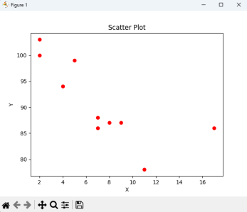
6. Write a Python program to create a box plot using Seaborn for analyzing the distribution of numerical data.
import seaborn as sns
import pandas as pd
import matplotlib.pyplot as plt
df = pd.DataFrame({
"Math": [88, 85, 90, 87, 93],
"Science": [92, 90, 85, 88, 91]
})
sns.boxplot(data=df)
plt.title("Box Plot")
plt.show()

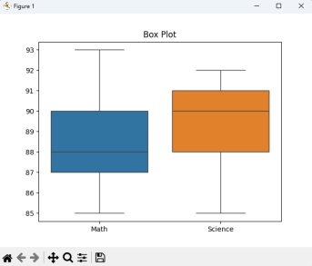
7. Write a Python program to create a violin plot using Seaborn to visualize data distribution across different categories.
import seaborn as sns
import matplotlib.pyplot as plt
tips = sns.load_dataset("tips")
sns.violinplot(x="day", y="total_bill", data=tips)
plt.title("Violin Plot of Bills by Day")
plt.show()
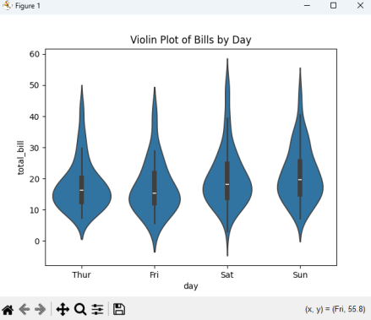
8. Write a Python program to create a heatmap using Seaborn for displaying data patterns using color intensity.
import seaborn as sns
import matplotlib.pyplot as plt
data = sns.load_dataset("flights").pivot(
index="month",
columns="year",
values="passengers"
)
sns.heatmap(data, cmap="YlGnBu", annot=True)
plt.title("Heatmap of Passengers")
plt.show()

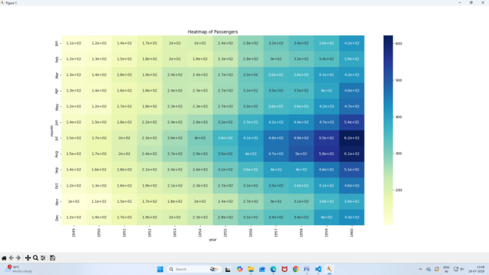
9. Write a Python program to create a pairplot using Seaborn to visualize relationships between multiple features of a dataset.
import seaborn as sns
import matplotlib.pyplot as plt
iris = sns.load_dataset("iris")
sns.pairplot(iris, hue="species")
plt.suptitle("Pairplot of Iris Dataset", y=1.02)
plt.show()

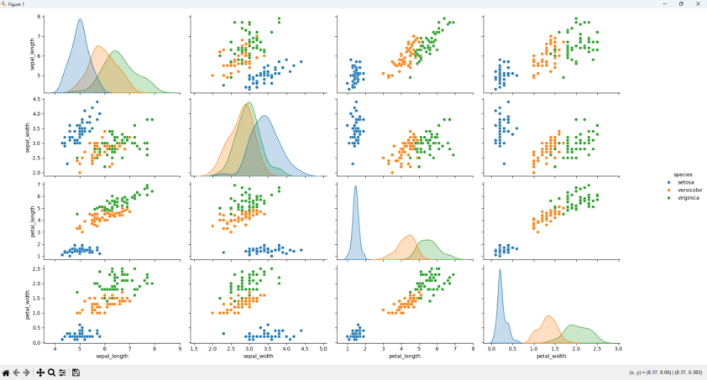
10. Write a Python program to create a count plot using Seaborn for displaying the frequency of records in different categories.
import seaborn as sns
import matplotlib.pyplot as plt
tips = sns.load_dataset("tips")
sns.countplot(x="day", data=tips)
plt.title("Count of Records per Day")
plt.show()

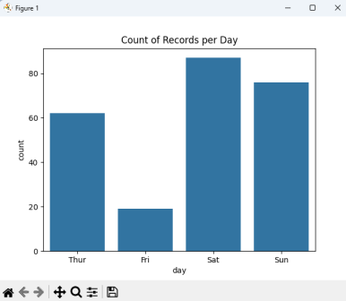

ASSIGNMENT 4 - STATISTICAL ANALYSIS & OUTLIER DETECTION
1. Write a Python program to read a dataset and display basic summary statistics using Pandas.
import pandas as pd
df = pd.read_csv("data_assignment4.csv")
print(df.describe())

2. Write a Python program to display summary statistics of categorical columns in a dataset.
import pandas as pd
df = pd.read_csv("data_assignment4.csv")
print(df.describe(include='object'))
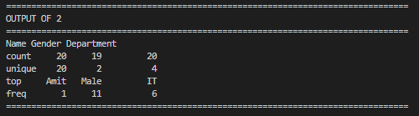
3. Write a Python program to calculate salary quantiles including Q1, median, and Q3 values.
import pandas as pd
df = pd.read_csv("data_assignment4.csv")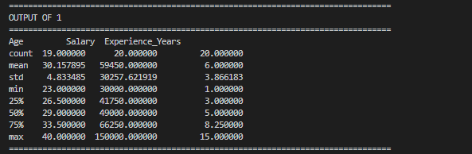
salary_quantiles = df["Salary"].quantile([0.25, 0.5, 0.75])
print(salary_quantiles)
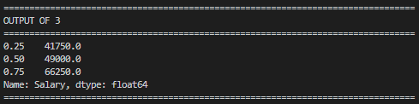
4. Write a Python program to detect salary outliers using the Interquartile Range (IQR) method.
import pandas as pd
df = pd.read_csv("data_assignment4.csv")
Q1 = df["Salary"].quantile(0.25)
Q3 = df["Salary"].quantile(0.75)
IQR = Q3 - Q1
outliers = df[
(df["Salary"] < Q1 - 1.5 * IQR) |
(df["Salary"] > Q3 + 1.5 * IQR)
]
print("Outliers:")
print(outliers)
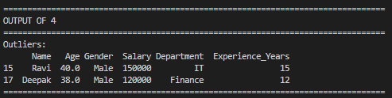
5. Write a Python program to visualize salary outliers using a boxplot.
import pandas as pd
import seaborn as sns
import matplotlib.pyplot as plt
df = pd.read_csv("data_assignment4.csv")
sns.boxplot(x=df["Salary"])
plt.title("Boxplot - Salary")
plt.show()
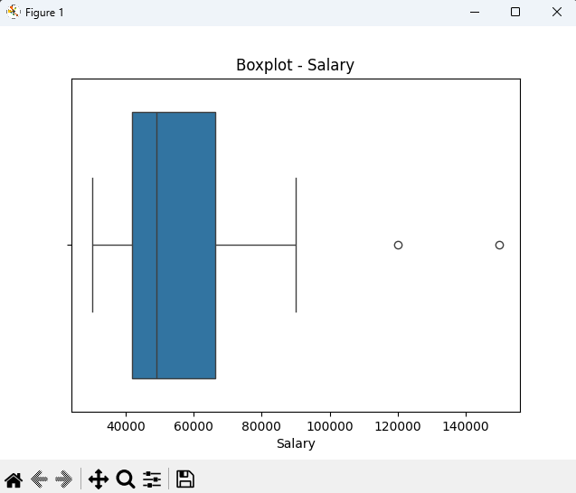
6. Write a Python program to detect salary outliers using the Z-Score method.
import pandas as pd
import numpy as np
from scipy import stats
df = pd.read_csv("data_assignment4.csv")
z_scores = np.abs(stats.zscore(df[["Salary"]]))
outliers = df[(z_scores > 3).any(axis=1)]
print("Outliers:")
print(outliers)
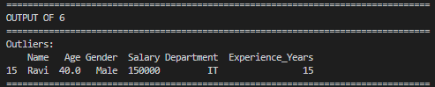
7. Write a Python program to handle salary outliers by applying the capping technique.
import pandas as pd
df = pd.read_csv("data_assignment4.csv")
cap_upper = df["Salary"].quantile(0.95)
cap_lower = df["Salary"].quantile(0.05)
df["Salary_Capped"] = df["Salary"].clip(
lower=cap_lower,
upper=cap_upper
)
print(df[["Salary", "Salary_Capped"]].head())
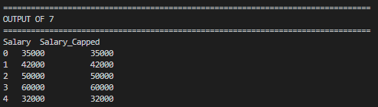
8. Write a Python program to calculate department-wise mean and standard deviation of salary.
import pandas as pd
df = pd.read_csv("data_assignment4.csv")
group_stats = df.groupby("Department")["Salary"].agg(
["mean", "std"]
)
print(group_stats)
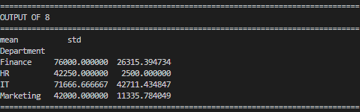
9. Write a Python program to identify missing values present in each column of a dataset.
import pandas as pd
df = pd.read_csv("data_assignment4.csv")
missing_values = df.isnull().sum()
print("Missing values per column:")
print(missing_values)
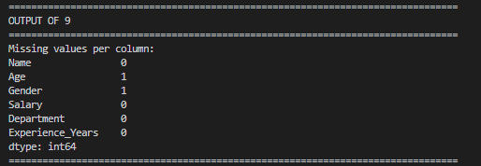
10. Write a Python program to replace salary outliers with the median salary value.
import pandas as pd
import numpy as np
df = pd.read_csv("data_assignment4.csv")
Q1 = df["Salary"].quantile(0.25)
Q3 = df["Salary"].quantile(0.75)
IQR = Q3 - Q1
median_salary = df["Salary"].median()
df["Salary_Replaced"] = np.where(
(df["Salary"] > Q3 + 1.5 * IQR) |
(df["Salary"] < Q1 - 1.5 * IQR),
median_salary,
df["Salary"]
)
print(df[["Salary", "Salary_Replaced"]].head())
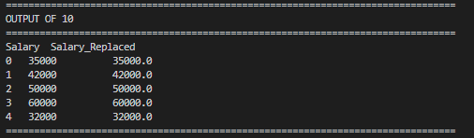

ASSIGNMENT 5 – REGRESSION ANALYSIS & CLASSIFICATION
1. Write a Python program to perform Simple Linear Regression using Experience and Salary.
import pandas as pd
from sklearn.linear_model import LinearRegression
df = pd.read_csv("data_assignment5.csv")
X = df[['Experience']]
y = df['Salary']
model = LinearRegression()
model.fit(X, y)
print("Intercept:", model.intercept_)
print("Coefficient:", model.coef_[0])
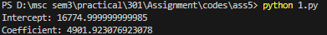
2. Write a Python program to predict salary for 5 years of experience using Linear Regression.
import pandas as pd
from sklearn.linear_model import LinearRegression
df = pd.read_csv("data_assignment5.csv")
X = df[['Experience']]
y = df['Salary']
model = LinearRegression()
model.fit(X, y)
predicted_salary = model.predict(pd.DataFrame([[5]], columns=['Experience']))
print("Predicted Salary for 5 years:", predicted_salary[0])
3. Write a Python program to visualize the Linear Regression line for Experience and Salary.
import pandas as pd
import matplotlib.pyplot as plt
from sklearn.linear_model import LinearRegression
df = pd.read_csv("data_assignment5.csv")
X = df[['Experience']]
y = df['Salary']
model = LinearRegression()
model.fit(X, y)
plt.scatter(X, y, color='blue')
plt.plot(X, model.predict(X), color='red')
plt.title("Experience vs Salary")
plt.xlabel("Years of Experience")
plt.ylabel("Salary")
plt.show()
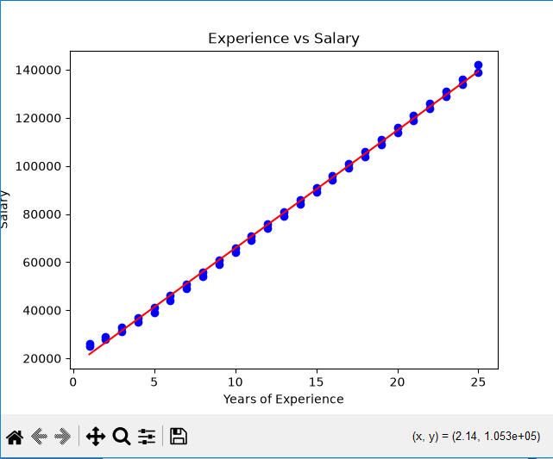
4. Write a Python program to perform Multiple Linear Regression using Experience, Age and Salary.
import pandas as pd
from sklearn.linear_model import LinearRegression
df = pd.read_csv("data_assignment5.csv")
X = df[['Experience', 'Age']]
y = df['Salary']
model = LinearRegression()
model.fit(X, y)
print("Coefficients:", model.coef_)
print("Intercept:", model.intercept_)
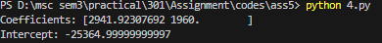
5. Write a Python program to perform Logistic Regression using Age and Income to predict Purchase status.
import pandas as pd
from sklearn.linear_model import LogisticRegression
df = pd.read_csv("data_assignment5.csv")
X = df[['Age', 'Income']]
y = df['Purchased']
model = LogisticRegression()
model.fit(X, y)
print("Coefficients:")
print(model.coef_)
print("Intercept:")
print(model.intercept_)
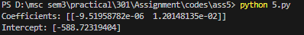
6. Write a Python program to predict purchase outcome using Logistic Regression.
import pandas as pd
from sklearn.linear_model import LogisticRegression
df = pd.read_csv("data_assignment5.csv")
X = df[['Age', 'Income']]
y = df['Purchased']
model = LogisticRegression()
model.fit(X, y)
prediction = model.predict( pd.DataFrame([[30, 45000]], columns=['Age', 'Income']))
print("Prediction (1=Yes, 0=No):", prediction[0])
7. Write a Python program to generate a classification report for Logistic Regression model.
import pandas as pd
from sklearn.linear_model import LogisticRegression
from sklearn.metrics import classification_report
df = pd.read_csv("data_assignment5.csv")
X = df[['Age', 'Income']]
y = df['Purchased']
model = LogisticRegression()
model.fit(X, y)
y_pred = model.predict(X)
print("Classification Report:")
print(classification_report(y, y_pred))
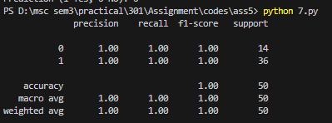
8. Write a Python program to visualize the confusion matrix of Logistic Regression model.
import pandas as pd
import matplotlib.pyplot as plt
import seaborn as sns
from sklearn.linear_model import LogisticRegression
from sklearn.metrics import confusion_matrix
df = pd.read_csv("data_assignment5.csv")
X = df[['Age', 'Income']]
y = df['Purchased']
model = LogisticRegression()
model.fit(X, y)
y_pred = model.predict(X)
cm = confusion_matrix(y, y_pred)
sns.heatmap(cm, annot=True, fmt='d', cmap='Blues')
plt.title("Confusion Matrix")
plt.xlabel("Predicted")
plt.ylabel("Actual")
plt.show()
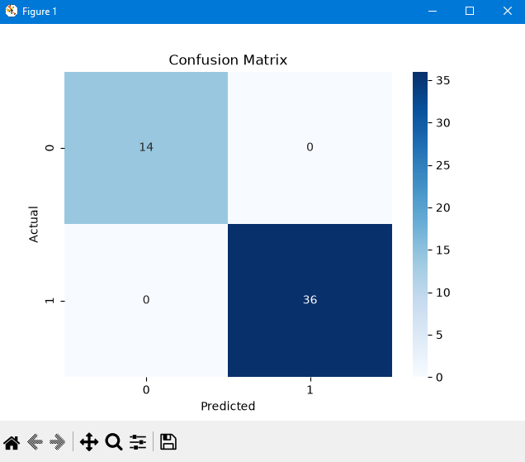
9. Write a Python program to calculate the accuracy score of Logistic Regression model.
import pandas as pd
from sklearn.linear_model import LogisticRegression
from sklearn.metrics import accuracy_score
df = pd.read_csv("data_assignment5.csv")
X = df[['Age', 'Income']]
y = df['Purchased']
model = LogisticRegression()
model.fit(X, y)
y_pred = model.predict(X)
accuracy = accuracy_score(y, y_pred)
print("Accuracy:", accuracy)
10. Write a Python program to visualize the Logistic Regression probability distribution.
import pandas as pd
import matplotlib.pyplot as plt
from sklearn.linear_model import LogisticRegression
df = pd.read_csv("data_assignment5.csv")
X = df[['Age', 'Income']]
y = df['Purchased']
model = LogisticRegression()
model.fit(X, y)
probabilities = model.predict_proba(X)[:, 1]
plt.hist(probabilities, bins=10, color='green')
plt.title("Purchase Probability Distribution")
plt.xlabel("Probability")
plt.ylabel("Frequency")
plt.show()
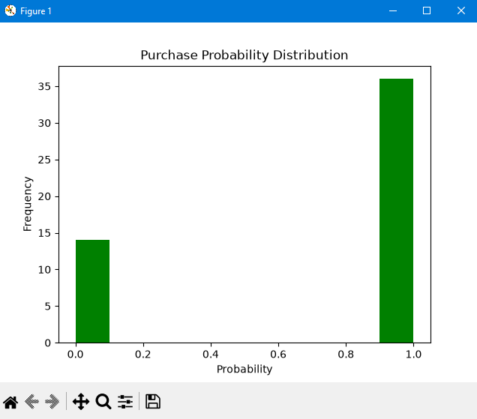

ASSIGNMENT 6 – TIME SERIES ANALYSIS & FORECASTING
1. Write a Python program to read a dataset and parse time series data using Pandas.
import pandas as pd
df = pd.read_csv( "data_assignment6.csv", parse_dates=['Date'])
df.set_index('Date', inplace=True)
print(df.head())
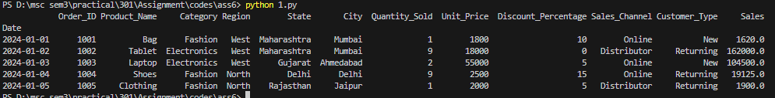
2. Write a Python program to visualize sales over time using a line plot.
import pandas as pd
import matplotlib.pyplot as plt
df = pd.read_csv( "data_assignment6.csv", parse_dates=['Date'])
df.set_index('Date', inplace=True)
df['Sales'].plot( title='Sales Over Time', figsize=(10, 4))
plt.ylabel('Sales')
plt.grid(True)
plt.show()
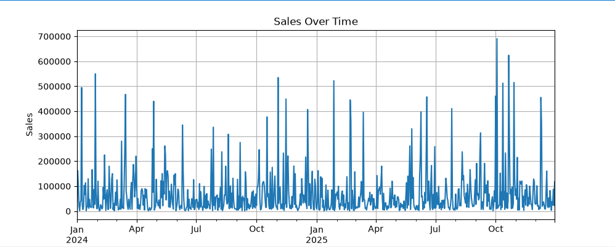
3. Write a Python program to perform monthly resampling and aggregation of sales data.
import pandas as pd
df = pd.read_csv( "data_assignment6.csv", parse_dates=['Date'])
df.set_index('Date', inplace=True)
monthly_sales = df['Sales'].resample('ME').sum()
print(monthly_sales.head())
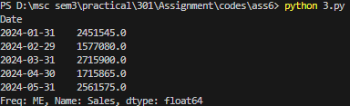
4. Write a Python program to calculate moving average using rolling mean method.
import pandas as pd
import matplotlib.pyplot as plt
df = pd.read_csv( "data_assignment6.csv", parse_dates=['Date'])
df.set_index('Date', inplace=True)
df['Rolling_Mean'] = df['Sales'].rolling( window=3).mean()
df[['Sales', 'Rolling_Mean']].plot()
plt.title('3-Month Rolling Average')
plt.show()
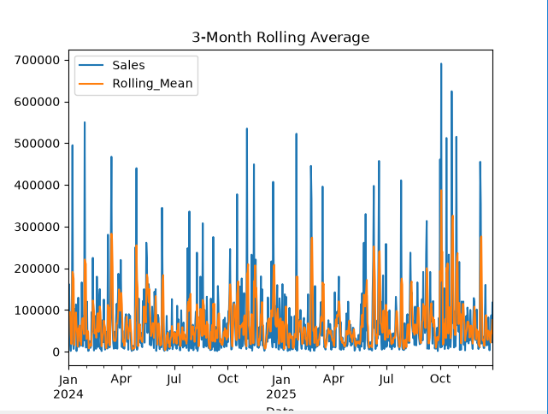
5. Write a Python program to perform seasonal decomposition of sales data.
import pandas as pd
import matplotlib.pyplot as plt
from statsmodels.tsa.seasonal import seasonal_decompose
df = pd.read_csv("data_assignment6.csv",parse_dates=['Date'])
df.set_index('Date', inplace=True)
decomp = seasonal_decompose( df['Sales'],model='additive',period=12)
decomp.plot()
plt.show()
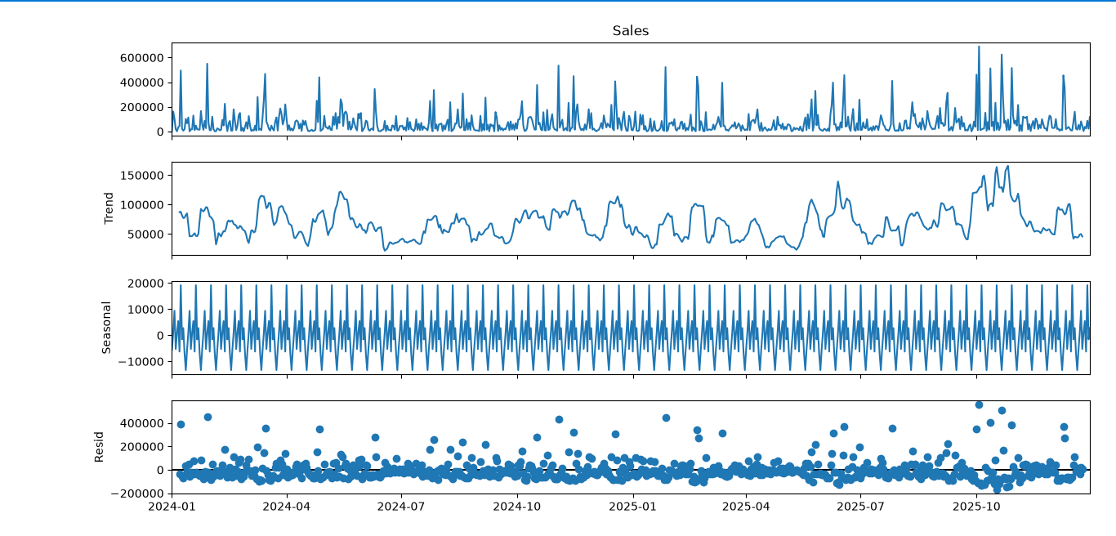
6. Write a Python program to perform ADF test for checking stationarity of time series data.
import pandas as pd
from statsmodels.tsa.stattools import adfuller
df = pd.read_csv( "data_assignment6.csv", parse_dates=['Date'])
df.set_index('Date', inplace=True)
result = adfuller( df['Sales'].dropna())
print("ADF Statistic:", result[0])
print("p-value:", result[1])
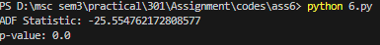
7. Write a Python program to remove trend from sales data using differencing method.
import pandas as pd
import matplotlib.pyplot as plt
df = pd.read_csv( "data_assignment6.csv",parse_dates=['Date'])
df.set_index('Date', inplace=True)
df['Sales_Diff'] = df['Sales'].diff()
df[['Sales', 'Sales_Diff']].plot( subplots=True)
plt.show()
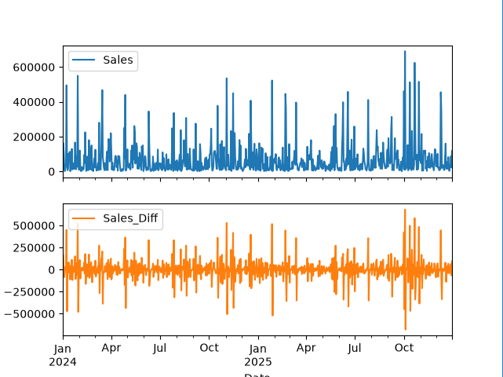

8. Write a Python program to generate Autocorrelation and Partial Autocorrelation plots.
import pandas as pd
import matplotlib.pyplot as plt
from statsmodels.graphics.tsaplots import plot_acf, plot_pacf
df = pd.read_csv( "data_assignment6.csv", parse_dates=['Date'])
df.set_index('Date', inplace=True)
plot_acf( df['Sales'].dropna(), lags=20)
plt.show()
plot_pacf( df['Sales'].dropna(), lags=20)
plt.show()
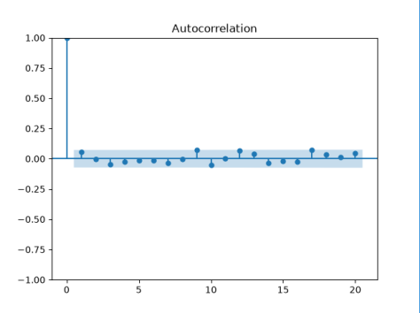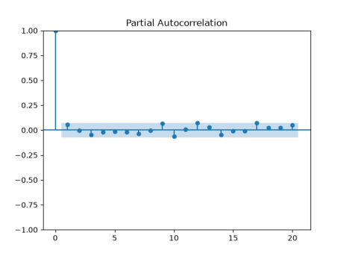
9. Write a Python program to perform ARIMA model forecasting for future sales.
import pandas as pd
from statsmodels.tsa.arima.model import ARIMA
df = pd.read_csv( "data_assignment6.csv", parse_dates=['Date'])
df.set_index('Date', inplace=True)
df = df.asfreq('D')
model = ARIMA( df['Sales'],order=(1, 1, 1))
model_fit = model.fit()
forecast = model_fit.forecast( steps=5)
print("Next 5 forecasts:")
print(forecast)
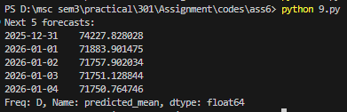
10. Write a Python program to plot forecast values against actual sales values.
import pandas as pd
import matplotlib.pyplot as plt
from statsmodels.tsa.arima.model import ARIMA
df = pd.read_csv( "data_assignment6.csv", parse_dates=['Date'])
df.set_index('Date', inplace=True)
df = df.asfreq('D')
model = ARIMA( df['Sales'], order=(1, 1, 1))
model_fit = model.fit()
forecast = model_fit.forecast( steps=5)
plt.plot( df['Sales'], label='Actual')
plt.plot( forecast.index,forecast, label='Forecast', color='red')
plt.legend()
plt.title('Forecast vs Actual Sales')
plt.show()
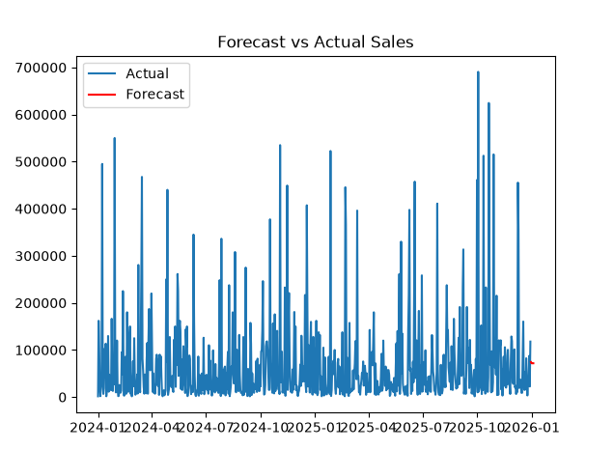

ASSIGNMENT 7 – PRACTICAL DATA CLEANING & EDA
1. Write a Python program to perform data cleaning and preprocessing on employee data using Pandas and NumPy.
import pandas as pd
import numpy as np
data = pd.read_csv("employee_data.csv")
print("Original Data:")
print(data)
data['salary'] = data['salary'].fillna(data['salary'].mean())
data['bonus'] = data['bonus'].fillna(data['bonus'].mean())
data['age'] = data['age'].fillna(data['age'].mean())
data['join_date'] = data['join_date'].ffill()
data = data.loc[:, ~data.columns.duplicated()]
data = data.drop_duplicates()
data.columns = [col.capitalize() for col in data.columns]
data['Join_date'] = pd.to_datetime(data['Join_date'],format='%d-%m-%Y')
data['Salary'] = pd.to_numeric(data['Salary'])
data['Bonus'] = pd.to_numeric(data['Bonus'])
data = data.dropna(thresh=len(data.columns)-2)
data['Salary_Normalized'] = (
(data['Salary'] - data['Salary'].min()) /
(data['Salary'].max() - data['Salary'].min())
)
print("\nCleaned Dataset:")
print(data)
print("\nData Information:")
print(data.info())
print("\nStatistical Summary:")
print(data.describe())
OUTPUT:
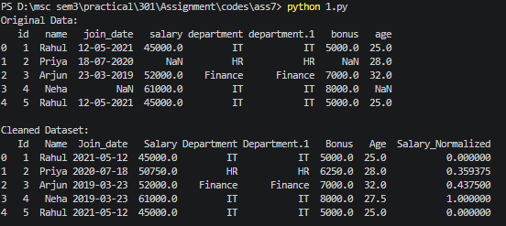
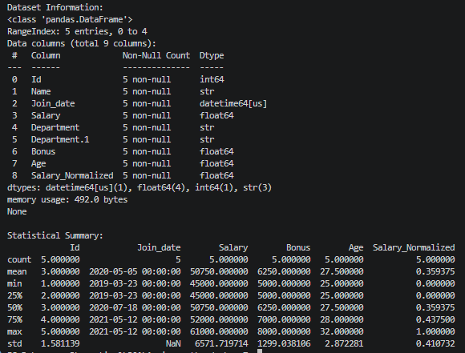
2. Write a Python program to perform data cleaning and preprocessing of customer sales data using Pandas and NumPy.
import pandas as pd
import numpy as np
data = pd.read_csv("customer_sales.csv")
print("Original Data:")
print(data)
data['amount'] = data['amount'].fillna(data['amount'].mean())
data['discount'] = data['discount'].fillna(data['discount'].mean())
data['age'] = data['age'].fillna(data['age'].mean())
data['purchase_date'] = data['purchase_date'].ffill()
data = data.loc[:, ~data.columns.duplicated()]
data = data.drop_duplicates()
data.columns = [col.capitalize() for col in data.columns]
data['Purchase_date'] = pd.to_datetime(data['Purchase_date'],format='%Y-%m-%d')
data['Amount'] = pd.to_numeric(data['Amount'])
data['Discount'] = pd.to_numeric(data['Discount'])
data = data.dropna(thresh=len(data.columns)-2)
data['Amount_Normalized'] = (
(data['Amount'] - data['Amount'].min()) /
(data['Amount'].max() - data['Amount'].min())
)
print("\nCleaned Dataset:")
print(data)
print("\nData Information:")
print(data.info())
print("\nStatistical Summary:")
print(data.describe())
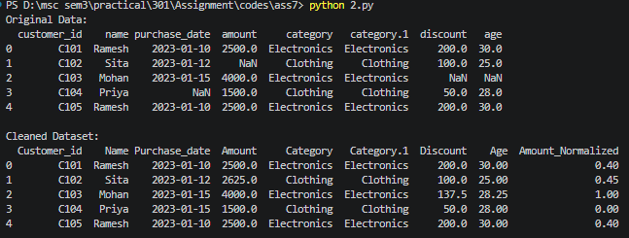
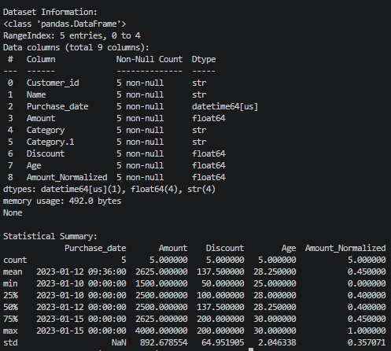
3. Write a Python program to perform data cleaning, transformation, normalization and exploratory data analysis on retail sales data.
import pandas as pd
import numpy as np
import matplotlib.pyplot as plt
import seaborn as sns
df = pd.read_csv("retail_sales.csv")
print("Initial Data:")
print(df.head())
df['Product'] = df['Product'].fillna("Unknown")
df['Quantity'] = df['Quantity'].fillna(df['Quantity'].median())
df['Price'] = df['Price'].fillna(df['Price'].mean())
df['Total_Sales'] = (df['Quantity'] * df['Price'])
df.drop_duplicates(inplace=True)
df['Date'] = pd.to_datetime(df['Date'])
df['Log_Sales'] = np.log1p(df['Total_Sales'])
df['Price_Normalized'] = (
(df['Price'] - df['Price'].min()) /
(df['Price'].max() - df['Price'].min())
)
print("\nData After Transformation:")
print(
df[
['Price','Price_Normalized','Total_Sales','Log_Sales']
].head()
)
print("\nSummary Statistics:")
print(df.describe())
plt.figure(figsize=(6,4))
sns.barplot(x="Category",y="Total_Sales",data=df,estimator=np.sum)
plt.title("Total Sales by Category")
plt.show()
plt.figure(figsize=(6,4))
sns.histplot( df['Price'],bins=10, kde=True)
plt.title("Distribution of Product Prices")
plt.show()
plt.figure(figsize=(6,4))
sns.boxplot(x="Category",y="Price",data=df)
plt.title("Outlier Detection in Product Prices")
plt.show()
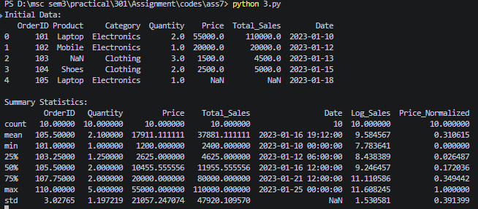
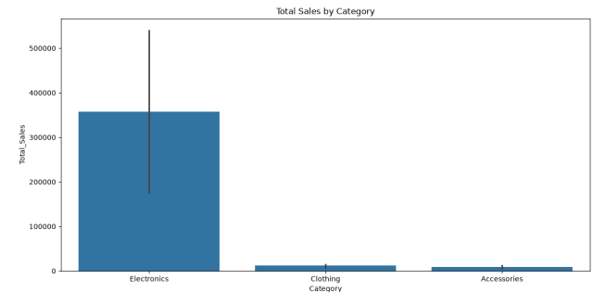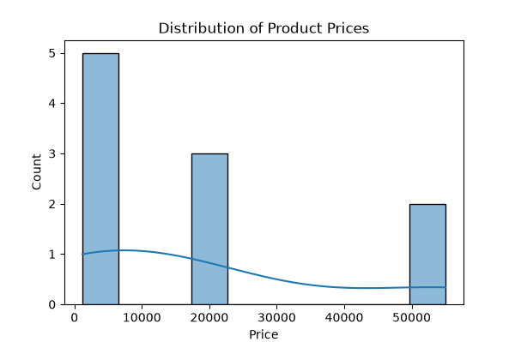
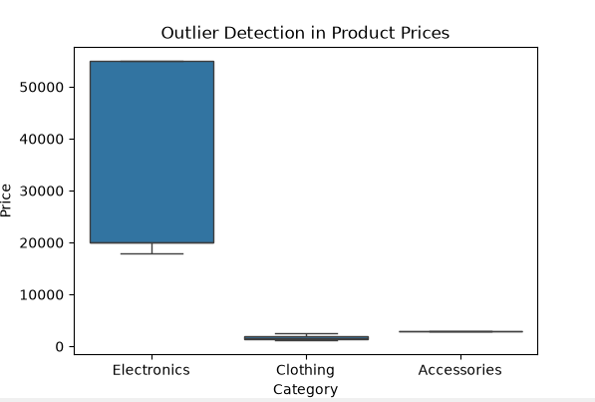

4. Write a Python program to perform data cleaning, preprocessing and basic analysis of sales data.
import pandas as pd
import numpy as np
import matplotlib.pyplot as plt
import seaborn as sns
df = pd.read_csv("sales_data.csv")
print("Original Data:")
print(df)
df['Quantity'] = df['Quantity'].fillna(df['Quantity'].mean())
df['Price'] = df['Price'].fillna(df['Price'].mean())
df['Total_Sales'] = df['Total_Sales'].fillna(df['Total_Sales'].mean())
df['Region'] = df['Region'].fillna(df['Region'].mode()[0])
df = df.drop_duplicates()
df = df[
['Sale_ID','Customer','Product',’Category','Quantity','Price',’Total_Sales','Date']
]
df.columns = [ col.capitalize() for col in df.columns]
df['Date'] = pd.to_datetime(df['Date'],format='%Y-%m-%d')
df['Quantity'] = pd.to_numeric(df['Quantity'])
df['Price'] = pd.to_numeric(df['Price'])
df['Total_sales'] = pd.to_numeric(df['Total_sales'])
df['Category_Code'] = ( df['Category'].astype('category').cat.codes)
df['Total_Sales_Normalized'] = (
(df['Total_sales'] - df['Total_sales'].min()) /
(df['Total_sales'].max() - df['Total_sales'].min())
)
filtered_data = df[ df['Total_sales'] > 5000]
print("\nCleaned Dataset:")
print(filtered_data)
print("\nData Information:")
print(filtered_data.info())
print("\nStatistical Summary:")
print(filtered_data.describe())
plt.figure(figsize=(6,4))
sns.barplot(x='Category', y='Total_sales',data=filtered_data,estimator=np.sum)
plt.title("Total Sales per Category")
plt.show()
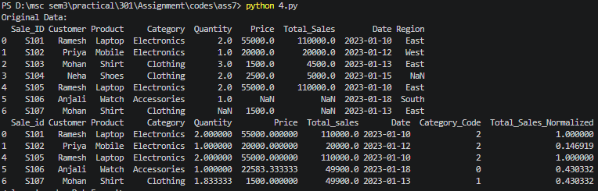
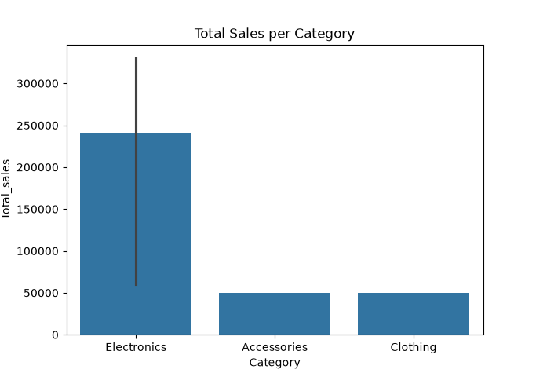
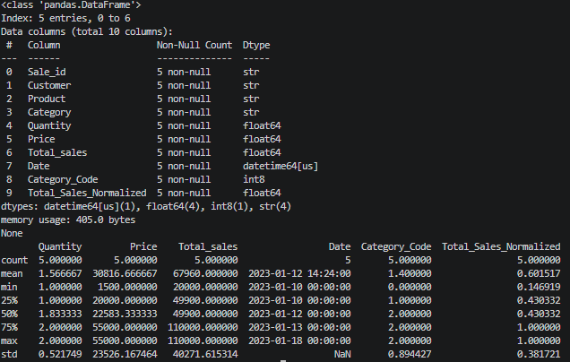

ASSIGNMENT 8 – ADVANCED VISUALIZATION USING SEABORN AND MATPLOTLIB
1. Write a Python program to apply Seaborn style to Matplotlib plots.
import matplotlib.pyplot as plt
import seaborn as sns
sns.set_theme(style="darkgrid")
x = [1, 2, 3, 4, 5]
y = [10, 12, 15, 18, 22]
plt.plot(x, y, marker='o', linestyle='-', color='blue', label="Trend")
plt.xlabel("X-axis")
plt.ylabel("Y-axis")
plt.title("Matplotlib Plot with Seaborn Theme")
plt.legend()
plt.show()
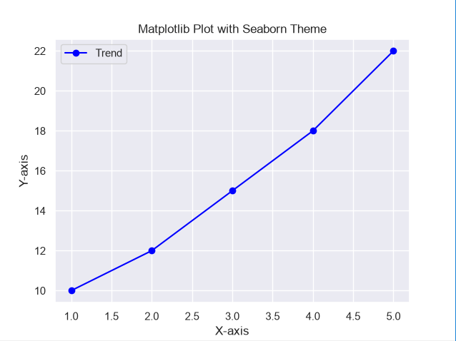
2. Write a Python program to customize a Seaborn line plot using Matplotlib functions.
import matplotlib.pyplot as plt
import seaborn as sns
import pandas as pd
data = pd.DataFrame({'Year':[2018,2019,2020,2021,2022],'Sales':[100,150,200,250,300]})
plt.figure(figsize=(8,5))
sns.lineplot(x='Year', y='Sales', data=data, marker='o')
plt.title("Yearly Sales Growth", fontsize=14, fontweight='bold')
plt.xlabel("Year", fontsize=12)
plt.ylabel("Total Sales", fontsize=12)
plt.xticks(rotation=45)
plt.grid(True, linestyle='--')
plt.show()
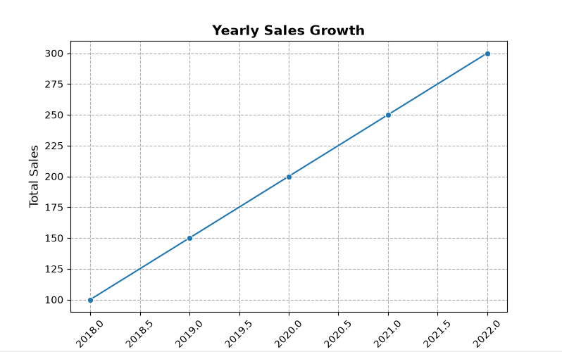
3. Write a Python program to overlay Seaborn and Matplotlib plots.
import numpy as np
import matplotlib.pyplot as plt
import seaborn as sns
x = np.linspace(0, 10, 20)
y = np.sin(x)
plt.figure(figsize=(8,5))
sns.lineplot(x=x, y=y, color='blue', label='Sine Wave')
plt.scatter(x, y, color='red', marker='o', label="Data Points")
plt.title("Seaborn Line Plot with Matplotlib Scatter Overlay")
plt.xlabel("X-axis")
plt.ylabel("Y-axis")
plt.legend()
plt.show()
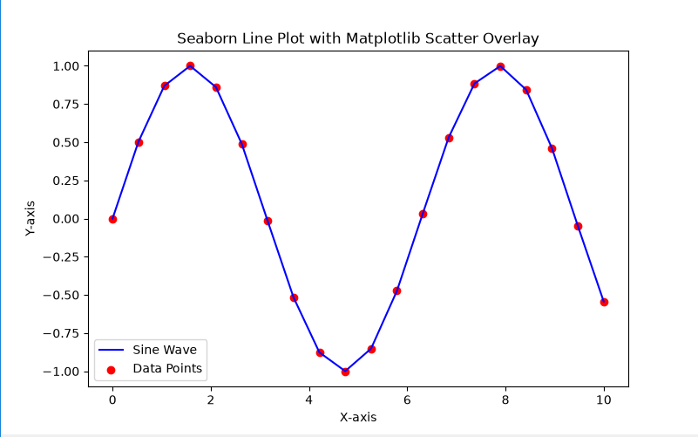
4. Write a Python program to enhance a Seaborn histogram using Matplotlib annotations.
import numpy as np
import matplotlib.pyplot as plt
import seaborn as sns
data = np.random.randn(1000)
plt.figure(figsize=(8,5))
sns.histplot(data, kde=True, bins=30, color='purple')
mean_value = np.mean(data)
plt.axvline(mean_value, color='red', linestyle='dashed', linewidth=2)
plt.text(mean_value + 0.1, 50, f'Mean: {mean_value:.2f}', color='red')
plt.title("Distribution with Seaborn and Matplotlib Customization")
plt.xlabel("Value")
plt.ylabel("Frequency")
plt.show()
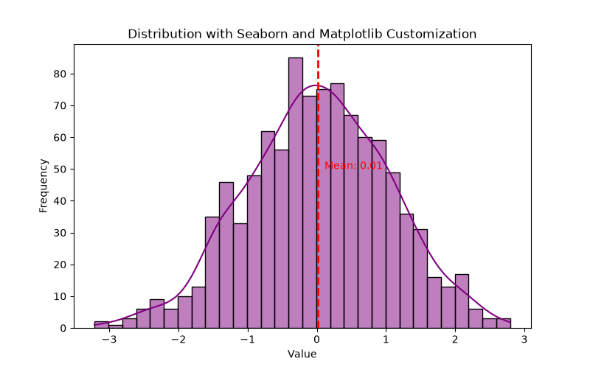

ASSIGNMENT 9 – INTERACTIVE VISUALIZATION USING BOOKEH
1. Write a Python program to hide the legend in a Bokeh plot.
from bokeh.plotting import figure, output_file, show
output_file("hiding_legend.html")
graph = figure(title="Bokeh Hiding Legend")
graph.vbar( x=1,top=5,width=1,color="violet", legend_label="Violet Bar")
graph.vbar( x=2,top=5, width=1,color="green",legend_label="Green Bar")
graph.vbar( x=3,top=5, width=1,color="yellow", legend_label="Yellow Bar")
graph.vbar( x=4,top=5, width=1,color="red",legend_label="Red Bar")
graph.legend.click_policy = "hide"
show(graph)

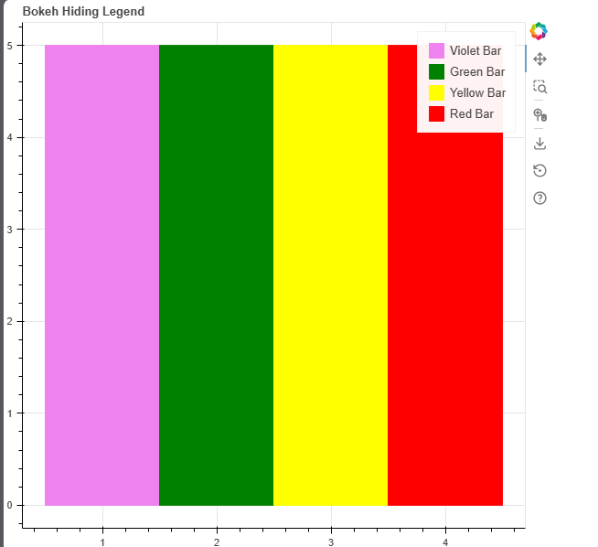

2. Write a Python program to mute the legend in a Bokeh plot.
from bokeh.plotting import figure, output_file, show
output_file("muting_legend.html")
graph = figure(title="Bokeh Muting Legend")
graph.vbar( x=1,top=5, width=1, color="violet",legend_label="Violet Bar",muted_alpha=0.2)
graph.vbar( x=2,top=5, width=1,color="green",legend_label="Green Bar",muted_alpha=0.2)
graph.vbar( x=3,top=5, width=1,color="yellow",legend_label="Yellow Bar",muted_alpha=0.2)
graph.vbar( x=4,top=5,width=1, color="red",legend_label="Red Bar",muted_alpha=0.2)
graph.legend.click_policy = "mute"
show(graph)
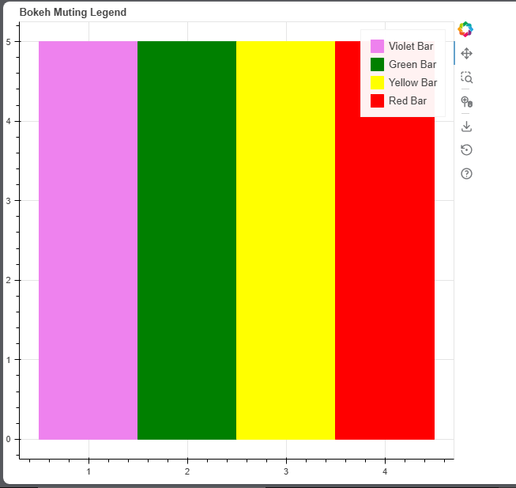

3. Write a Python program to add different widgets to a Bokeh plot.
from bokeh.io import show
from bokeh.layouts import column
from bokeh.models import (
Button,CheckboxGroup,CustomJS,RadioGroup,Slider,Dropdown)
button = Button(label="GFG")
button.js_on_click( CustomJS(code="""console.log('button: click!',this.toString()) """))
labels = ["First", "Second", "Third"]
checkbox_group = CheckboxGroup(
labels=labels,active=[0, 2])
checkbox_group.js_on_change(
"active", CustomJS(code="""console.log('checkbox_group: active=' + this.active,this.toString())"""))
radio_group = RadioGroup( labels=labels,active=1)
radio_group.js_on_change("active",
CustomJS(code="""console.log('radio_group: active=' + this.active, this.toString())"""))
slider = Slider(start=1,end=20,value=1,step=2, title="Slider")
slider.js_on_change("value",
CustomJS(code="""console.log('slider: value=' + this.value,this.toString())"""))
menu = [ ("First", "First"),("Second", "Second"),("Third", "Third")]
dropdown = Dropdown(label="Dropdown Menu",button_type="success",menu=menu)
dropdown.js_on_event("menu_item_click",
CustomJS(code="""console.log('dropdown: ' + this.item,this.toString())""" ))
layout = column( button, checkbox_group,radio_group,slider, dropdown)
show(layout)
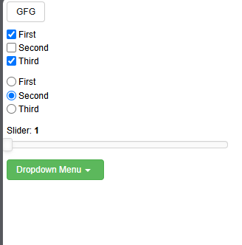

4. Write a Python program to create a Tab Widget in Bokeh.
from bokeh.plotting import figure, show
from bokeh.models import TabPanel, Tabs
fig1 = figure(width=300, height=300, title="Tab 1")
x = [1, 2, 3, 4, 5]
y = [5, 4, 3, 2, 1]
fig1.line(x,y,line_color="green",line_width=2)
fig2 = figure(width=300,height=300,title="Tab 2")
fig2.line( y,x, line_color="red",line_width=2)
tab1 = TabPanel(child=fig1,title="Tab 1")
tab2 = TabPanel(child=fig2,title="Tab 2")
all_tabs = Tabs(tabs=[tab1, tab2])
show(all_tabs)

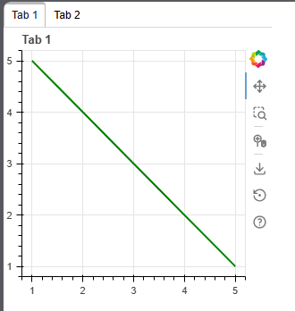

ASSIGNMENT 10 -

ASSIGNMENT 11 -

ASSIGNMENT 12 -

